# "Day 4 - Dynamic Frontend Components- HomeAura”

## Here is a proper description on what I have done in my day 4 task of Hackathon..

## Key Components Built:

## Product Listing Component:

• I implemented a dynamic product listing that renders product data in a grid layout.

• The component displays essential fields such as:

* **Product Name**: The name of the product displayed for users.
* **Price**: The price of each product.
* **Image**: A product image to help users identify the product visually.  
  This component helps to showcase a collection of products effectively in an organized manner.

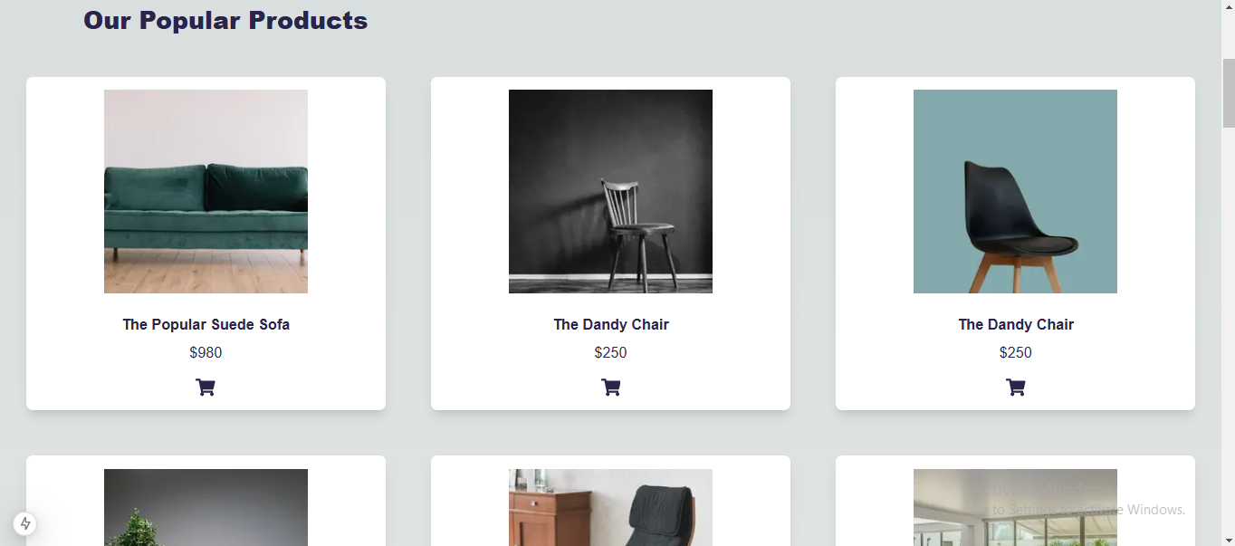

## Product Detail Component:

• Each page provides detailed information about a specific product. The details include:

* Implemented this component by fetching product data from **Sanity CMS** using its API.
* The slug acts as a unique identifier for each product, ensuring that the correct product details are dynamically displayed on the corresponding page.
  1. **Product Description**: A detailed description that explains the features and specifications of the product.
  2. **Price**: The price of the specific product for purchasing consideration.  
     This component allows users to view in-depth information about a product they are interested in.

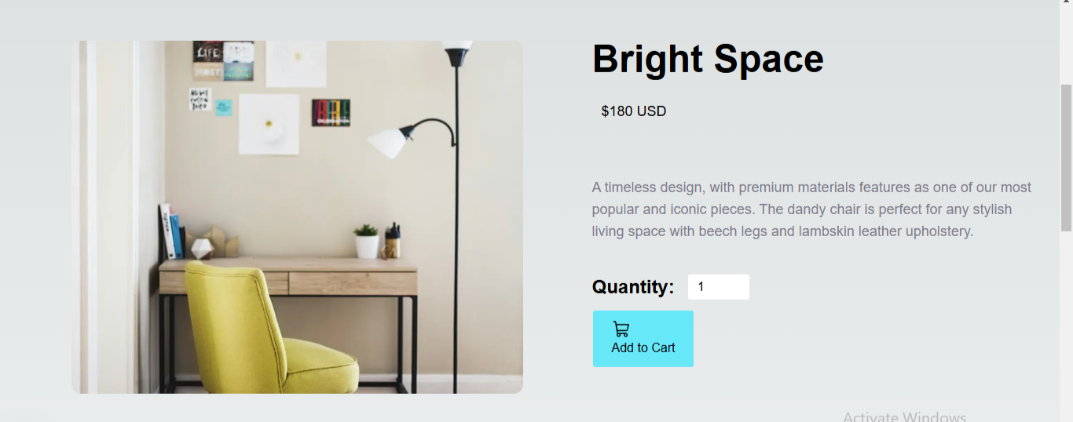

## Cart Component:

* Developed the cart component to display the products that a user adds to their shopping cart.
* It shows:
* **Items Added**: The products the user has added to their cart.
* **Quantity**: The number of units of each product added.
* **Total Price**: The total amount for the items in the cart, including any updates when the quantity changes.
* The component uses state management to track and update cart items dynamically, making the shopping experience seamless.

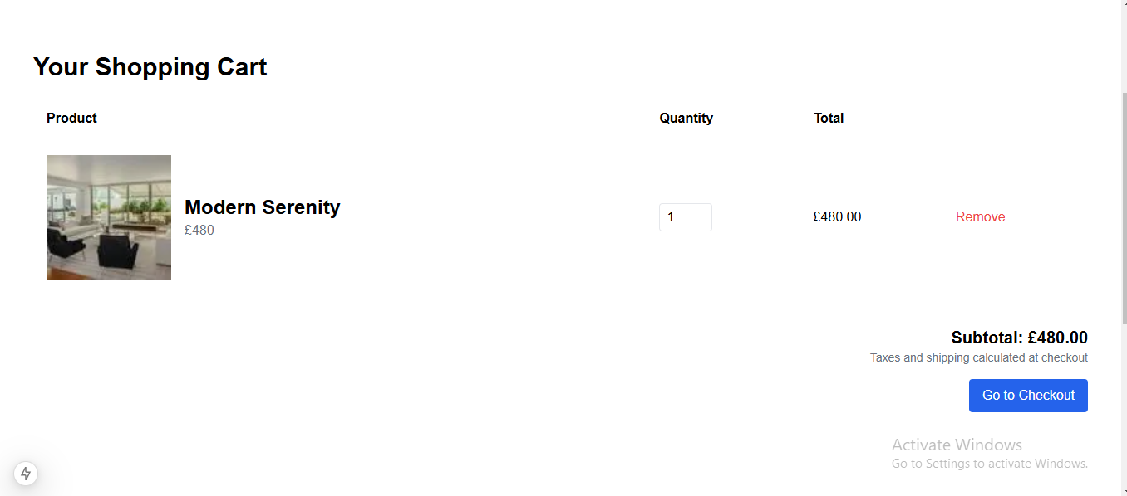

## Pagination Component:

* I developed the pagination component to improve the usability of product listings.
* This component helps in breaking down large product lists into smaller, more manageable pages.
* I included features like:
  + **Previous and Next Buttons**: For easy navigation between pages.
  + **Numbered Pagination**: To allow users to jump directly to a specific page in the list.  
    Pagination ensures that users can navigate through the product catalog without being overwhelmed by too many items on a single page.

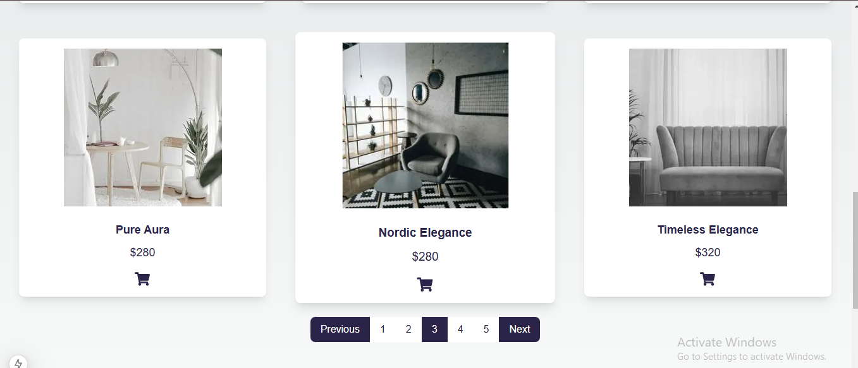

## Footer and Header Components:

• I created consistent footer and header components that are present across all pages of the site.

• The header includes essential navigation links to the main pages of the site, such as:

* **Home, About, Products**: Directs users to key areas of the site.

• The footer includes additional information and links relevant to the site, ensuring a consistent experience.

• Both components are fully responsive, ensuring a smooth user experience on different screen sizes and devices. I also focused on making them accessible to all users, following best practices in web design

## Screenshot of Header Component:

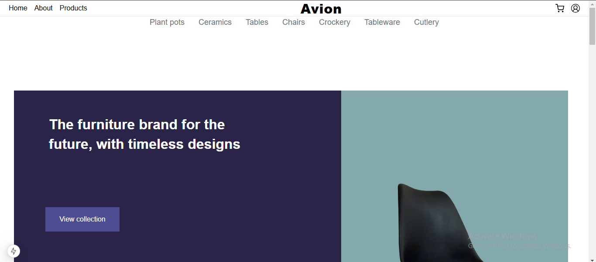

## Screenshot of Footer Component:

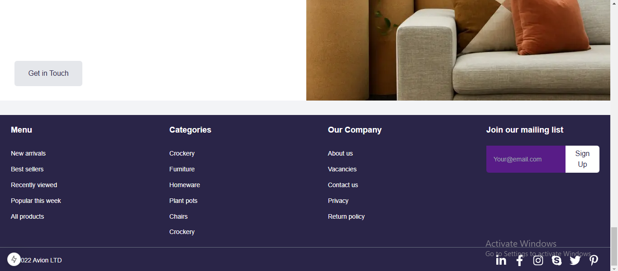

## Related Products Component:

* Shown related products below the product details page to users find their related products easily from here
* They can just click on the product they want and the product with full detail page will be open.

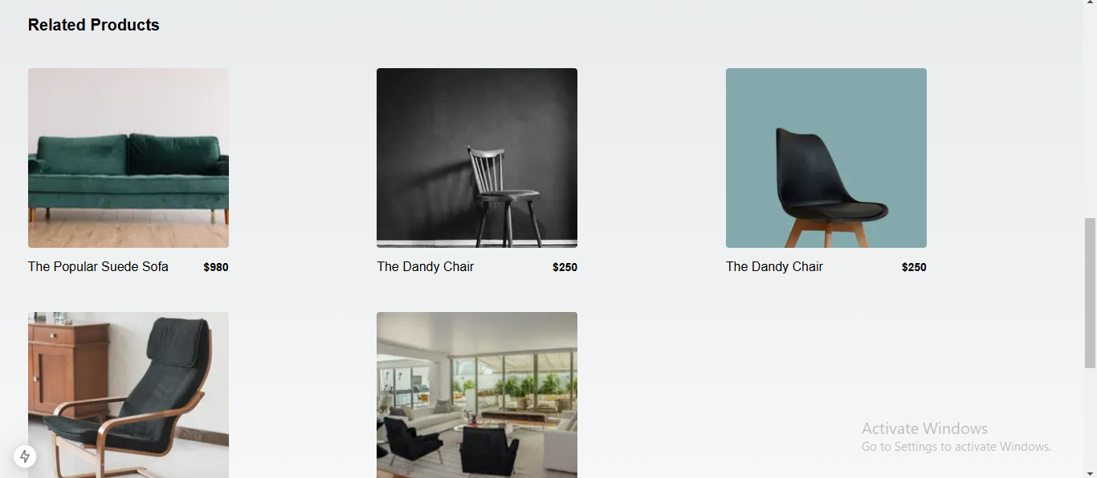

## Products and Toast Integration:

* Implemented a **toast notification** system to enhance user interaction and provide instant feedback.
* Added functionality to display a toast message whenever a user:  
  a. Clicks on the **"Add to Cart"** button for any product.  
  b. Interacts with the **cart icon**, confirming actions like adding items to the cart.
* The toast message displays a confirmation (e.g., *"Added to Cart"*) to notify the user that their action was successful.

## Screenshot Of Toast Integration:

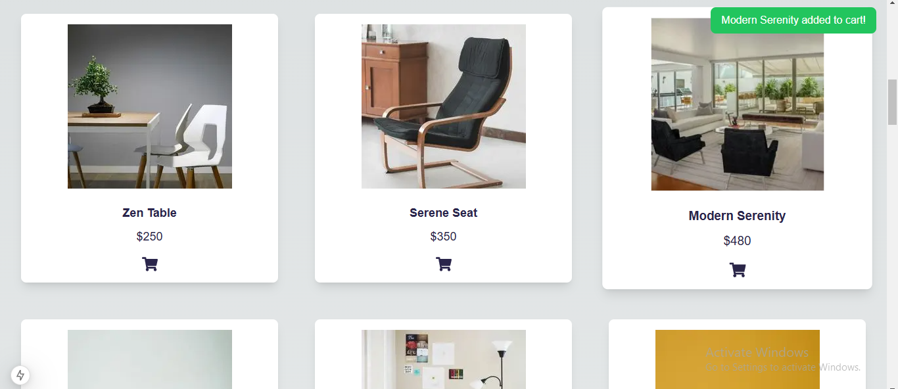

## Wishlist Component:

* Developed the wishlist component to allow users to save their favorite products for future reference or purchase.  
  • It shows:  
  • Items Saved: The products the user has added to their wishlist.  
  • Product Details: Key information like price and description of each saved item.  
  • Option to Add to Cart: Users can move products from the wishlist to the shopping cart with a single click.  
  • The component uses state management to track saved items and dynamically update the wishlist, improving the user experience.

## Screenshot of wishlist:

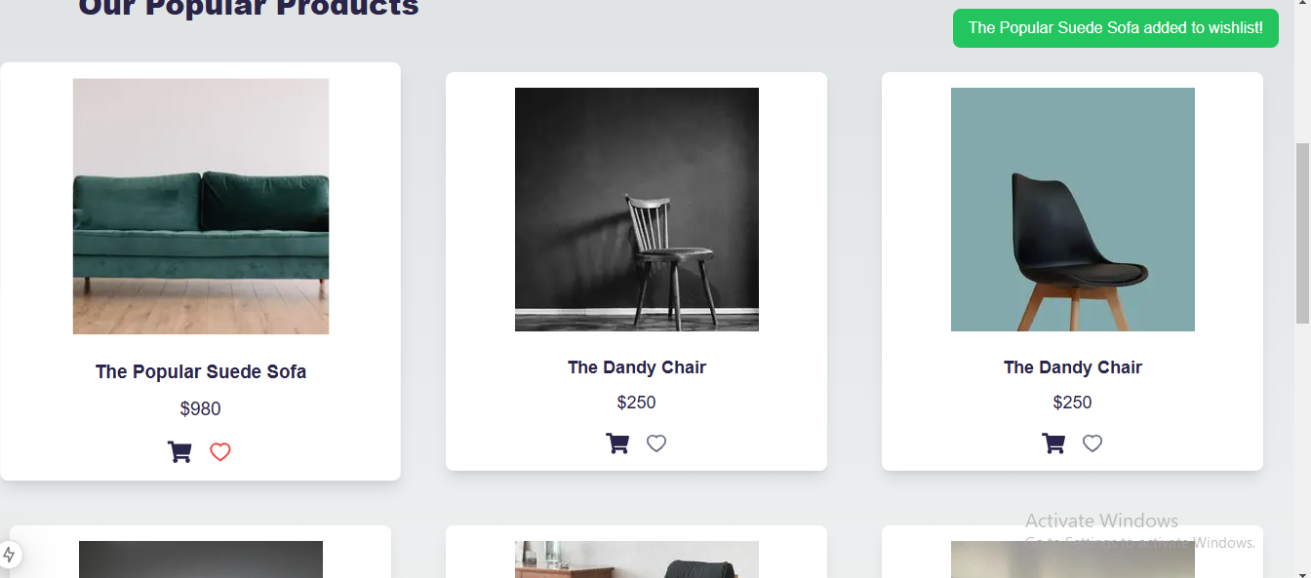

## Checkout Flow Component:

* A multi-step form to collect customer details, billing and shipping addresses, and payment information, with conditional steps for easy navigation.
* An order summary page that displays customer details, addresses, and payment method after submission, along with cart validation to ensure items are added before proceeding.

## Screenshot of Checkout:

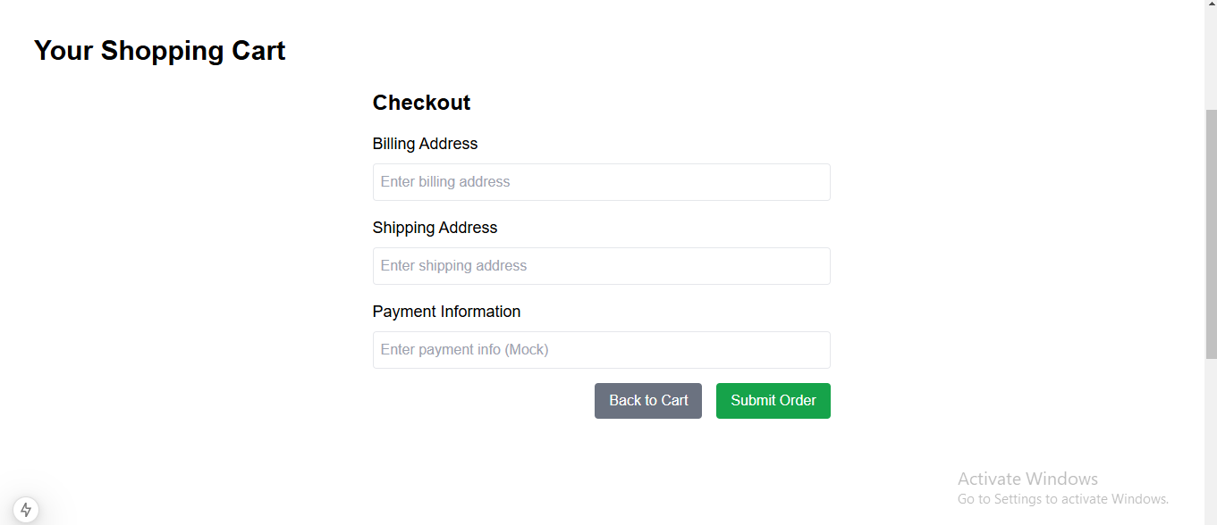

**Technical Report Summary:**

• **Steps taken to build and integrate components:**

Components were first designed based on the project requirements.

* Then, the integration of components was done by following the specific layout structure.
* Each component was tested for functionality before moving on to the next phase.
* Data for the components was fetched from **Sanity CMS** using its API to ensure dynamic and real-time updates.
* • Each component was thoroughly tested for functionality and responsiveness before moving on to the next phase.

• **Challenges faced and solutions implemented:**

* **Challenge:** Ensuring responsiveness on different screen sizes.  
  **Solution:** Utilized Tailwind CSS media queries to handle responsiveness.
* • Managing state effectively across components, especially for features like the cart.  
  **Solution:** Utilized React state management tools such as useState and useContext to track and manage data efficiently.
* • **Challenge:** Fetching and displaying dynamic product data while maintaining performance.  
  **Solution:** Integrated **Sanity CMS** to fetch real-time data using GROQ queries and ensured optimal API usage for dynamic routing in Next.js.
* • **Challenge:** Handling unique product slugs for dynamic routing and rendering.

• **Best practices followed during development:**

* Keeping code modular and reusable.
* Writing clear and concise comments for better understanding.
* Following accessibility standards for a more inclusive web.
* • Managing state effectively across components, especially for features like the cart.  
  **Solution:** Utilized React state management tools such as useState and useContext to track and manage data efficiently.
* • **Challenge:** Fetching and displaying dynamic product data while maintaining performance.  
  **Solution:** Integrated **Sanity CMS** to fetch real-time data using GROQ queries and ensured optimal API usage for dynamic routing in Next.js.
* • **Challenge:** Handling unique product slugs for dynamic routing and rendering.

# Checklist for Day 04:

|  |  |  |
| --- | --- | --- |
| **Self-Validation Checklist** |  |  |

|  |  |  |
| --- | --- | --- |
| Frontend Component Development | ✔ |  |

|  |  |  |
| --- | --- | --- |
| Styling and Responsiveness | ✔ |  |

|  |  |  |
| --- | --- | --- |
| Code Quality | ✔ |  |

|  |  |
| --- | --- |
| Documentation and Submission | ✔ |

By: Duaa Pirzada